
GIS Library Tutorials – Introduction to ArcGIS Online - 2

Import your OSi boundary data into ArcGIS Online

Left click on the Add Data option (clicking on either the + symbol, the word Add or the pull-down arrow will open the same menu of options)

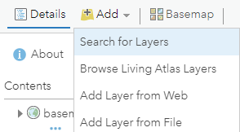
Left click on Search for Layers

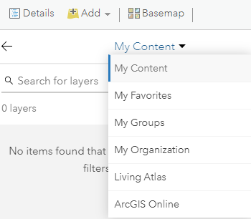
Left click on the pull-down arrow next to My Content

This opens a menu of options – left click on ArcGIS Online
In Search for layers type the data or name of organisation you are looking for

Freely available layers of data have been added by organisations, including the CSO and OSi

You can also search for layers of data by type, e.g., archaeology, fauna, health, climate, transport, rivers, etc

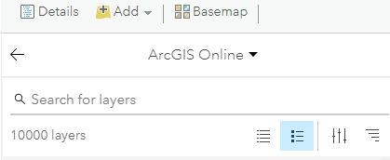

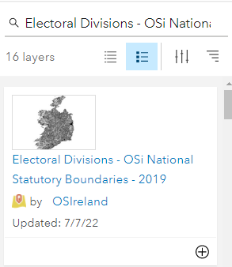
Type in the search Electoral Divisions - OSi National Statutory Boundaries – 2019 and press the return key on your keyboard

The result (s) will appear in the box

To read the details for a layer, left click on the blue layer title – this will open a new window with a description and all of the information about the layer
To add this layer to the map, left click on the + button

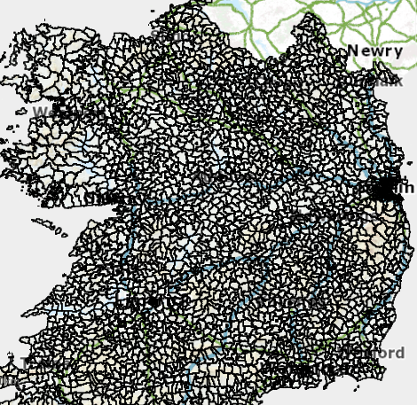

The electoral divisions will now be visible on the map

Does not matter at all if the boundaries on your map are shown in a completely different colour.

If you can’t see these boundary lines – left click on the Details tab and then click on the Content icon

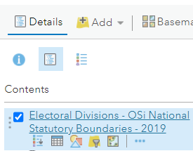
Hover with your mouse over the layer name Electoral Divisions– it will change to blue

Left click on the 3 horizontal blue dots

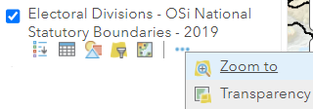
In the menu which opens left click on Zoom to

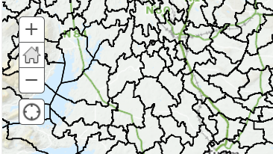
To see the boundaries more clearly, left click on the + on the map to zoom in

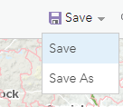
Left click on the down arrow next to Save and left click on Save As

It is important to save regularly in case your internet connection fails, and you lose your work
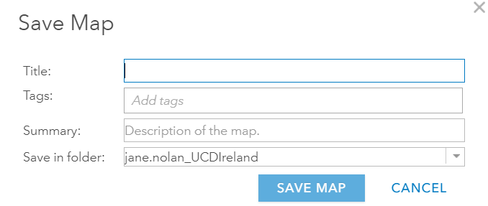

Type in your Title, for this example you can call it Ireland_ your name Practice Map

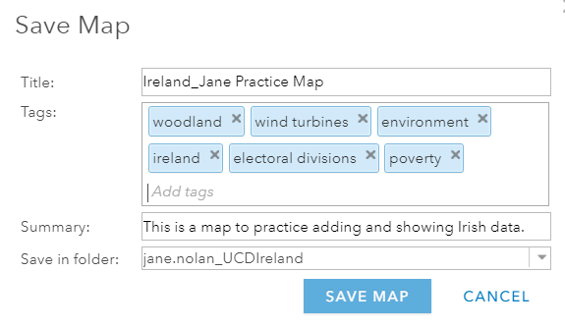
To add Tags (these are keywords or subject terms to help you find this map) type a keyword or a phrase and press the return key on your keyboard after you type each one.
Next, you can type in a summary describing what the map is about or what it will show, e.g., This is a map to practice adding and showing Irish data.

Left click on Save Map The map will save to your ArcGIS Online account

Left click on Details and then left click on Content and then hover with your mouse pointer over the layer name Electoral Divisions

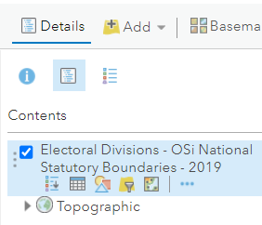
When you hover with your mouse you will see icons displayed.
The checkbox is ticked, and this means the Electoral Divisions boundaries are visible on the map.
Left click in the checkbox if you wished to temporarily hide / remove the boundaries.

From left to right the icons are:

Show Legend this will display a Legend for the layer selected
Show Table this opens the Attribute Table for the layer selected
Change Style allows you to change and customise the layer symbol
Filter allows you to filter out specific features you want to exclude from the map
Perform Analysis tools for running queries and analysing the data
More Options contains additional useful tools (we will use some of these later)

How to change the symbology of the
Electoral Divisions layer

Left click on the Change Style icon 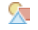

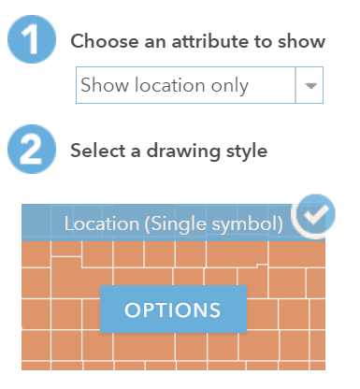
In the Choose an attribute to show field, leave the default setting as Show location only

In Select a drawing style field, left click on Options

This opens a new window which shows the Symbols –the symbol for the Electoral Division boundary is a polygon with a black outline (yours may be different – it will match the appearance of the boundary line on your map).

Hover over the word Symbols and you will see the box with the text Change Symbols appear
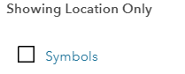

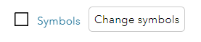
Left click on the word Symbols or on the symbol itself to make changes to the symbol

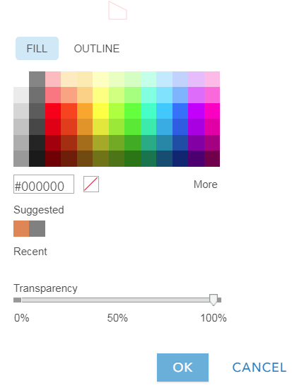
This opens a window where you can change the style:

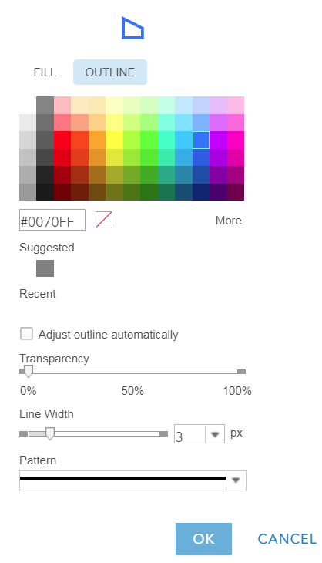
Left click on the word OUTLINE

Left click in one of the coloured squares (blue in this example)

Left click on the Line Width slider and drag to the right to increase the width of the line

Left click on OK

The map will be immediately updated to show this new symbology
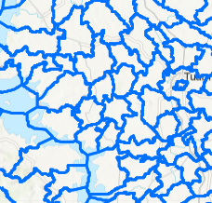

Whatever part of the country you have selected, or the colour of outline for the polygon, if you left click on the map, the information related to the Electoral Division you have clicked on will appear in a new window

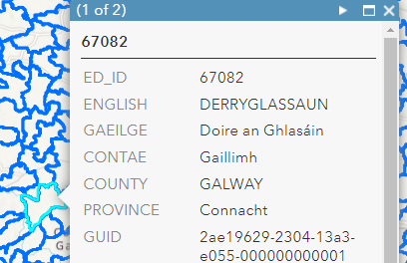

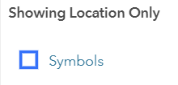
To change the style again, left click on the word Symbols (or on the blue outlined polygon)

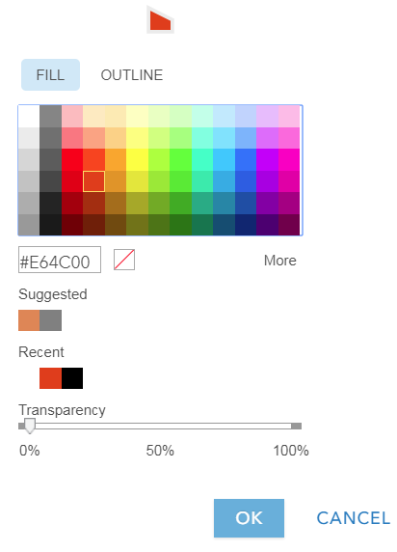
Left click on the word OUTLINE

Left click in one of the very light grey coloured squares

Left click on FILL and left click in one of the coloured squares (reddish brown in this example)

Left click on OK

The map will be immediately updated to show this new symbology

This brings you to the previous screen

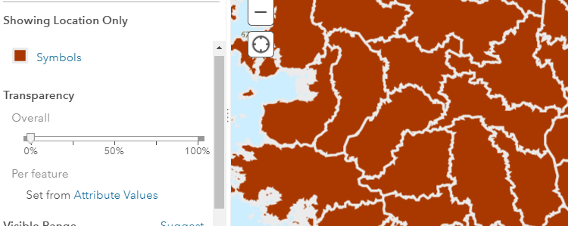

You can change the look of the map in another way:
Left click on the tab on the Transparency slider and drag it along the bar

This lets you alter the appearance of your map so that the polygons and outlines are halfway between completely opaque (0%) or completely transparent (100%)

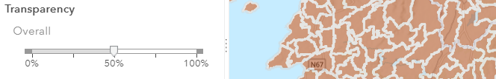


Left click on OK

This brings you to the previous screen
Left click on DONE

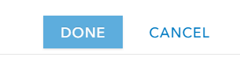

Along the top of the map left click on Save and from the menu left click on Save

